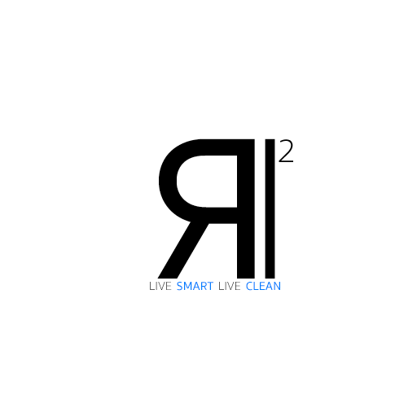

**Big Data Collecting and Analytics Platform for Strategic Product Development**

Antonio acquavia, Lorenzo Barigliano, Matilde Mazzini, Gianluca Serao

## Request for proposal

In this request for proposal there are the requirements for an open and competitive process for a software furniture. Proposal will be accepted until 4:30 pm May 30, 2020. Any proposal received after the end date will be rejected. Contract terms and condition will be negotiated with the winning bidder for this RFP. Contractual terms and condition will be reviewed by the IR2 legal department and will include a non-disclosure agreement, scope, budget, schedule and all the items pertaining to the project.

## Introduction/Background

IR2 operates in Italy and Europe and builds household robots for cleaning. Our products have high-quality components, innovative software and design, and relies on an advanced research and development department that collaborates with the world most important robotic institutes such as Istituto Italiano di Tecnologia, Centro di ricerca E. Piaggio and Politecnico di Milano. Currently, for our processes we use a custom web-application that runs on a Microsoft Azure cloud-based system. Moreover, we have a website, on which customers can buy our products and write aftersales reviews, and a mobile application through which customers can manage their robots and report problems. Therefore, it was decided to improve the managing of the output data coming from our research and development department and integrate those data with customers feedbacks to improve the product development process.

## Objectives

The objective of this project is to improve our products development process by creating a platform able to integrate and manage huge quantity of data coming from different sources.

## Scope of Work

The scope of this project is to design, implement and licensing the strategic product development software for IR2. Project works includes:

1. A development of a storage platform able to manage big data.
2. A development of a data collecting and merging tool that retrieve and merge research and development department data and customer reviews from our website, our mobile application and our social network profiles.
3. A development of an analytics system for the stored data that includes predictive models.
4. A development of a dashboard in our web-application from which our employees can access and visualize data and reports.
5. Integration with our existing system.

The software should respect the following requirements:

* 1. The system should be compatible with Azure.
  2. The dashboard should be user-friendly and is easy to navigate.
  3. The system should be integrated in our existing web-application.
  4. The system should reduce at minimum the risk of data losses.
  5. The data should be visualized for type of product and date.
  6. The system should forecast an approval rating per product
  7. The system should show tag clouds and histograms of review's trending topic.
  8. The system should have the R&D datasheet search by keywords.
  9. The system should have the reviews search by keywords.
  10. The system should show reports on past selling trends along with forecasted selling trends.
  11. The system should show R&D reports related with topic based on customer reviews.
  12. The system should identify the most active customers.
  13. The system should be compliant with the GDPR.

## Milestones

For this project we set up the following milestones:

Detailed milestones with corresponding deliverables:

* 1. Project kick-off (22 June 2020).
  2. Overall system design proposal document (29 June 2020).
  3. Overall system architecture proposal document (6 July 2020).
  4. Dashboard design proposal with mokups (13 July 2020).
  5. First software demo with report of implemented features and performed tests (20 July 2020).
  6. Second software demo with report of implemented features and performed tests (17 August 2020).
  7. Third software demo with report of implemented features and performed tests (14 September 2020).
  8. Fourth software demo with report of implemented features and performed tests (12 October 2020).
  9. Final dashboard design with mokups (19 October 2020).
  10. Final system prototype and user manual (16 November 2020).
  11. Final report of performed tests and system deployment (14 December 2020).

## WBS

## Budget

All proposal must include cost to meet the project requirements described in the project scope. Pricing should be listed for each of the following items:

* 1. Project initiation and planning.
  2. Additional IaaS resources rent.
  3. Software development.
  4. Software testing.
  5. Software deployment.

IR2 expects to complete the project with a budget of 250000 EUR, excluding rent costs for IaaS.

## Request documents

All bid should include a preliminary design of the solution, a detailed description of how it will be developed, what technologies will be used and a detailed description of costs with fees. Moreover, if the proposed IaaS is different from Microsoft Azure, bidders should provide a description of the features of that IaaS.

## Evaluation criteria

IR2 will evaluate bidders’ proposals on the following criteria:

* Overall proposal suitability: the proposed solution should meet the scope of this project.
* Integration and performance: how well the bidders’ proposed system is integrated with our existing system.
* Value and cost: bidders will be evaluated on the cost of the proposed solution based on the work to be performed.